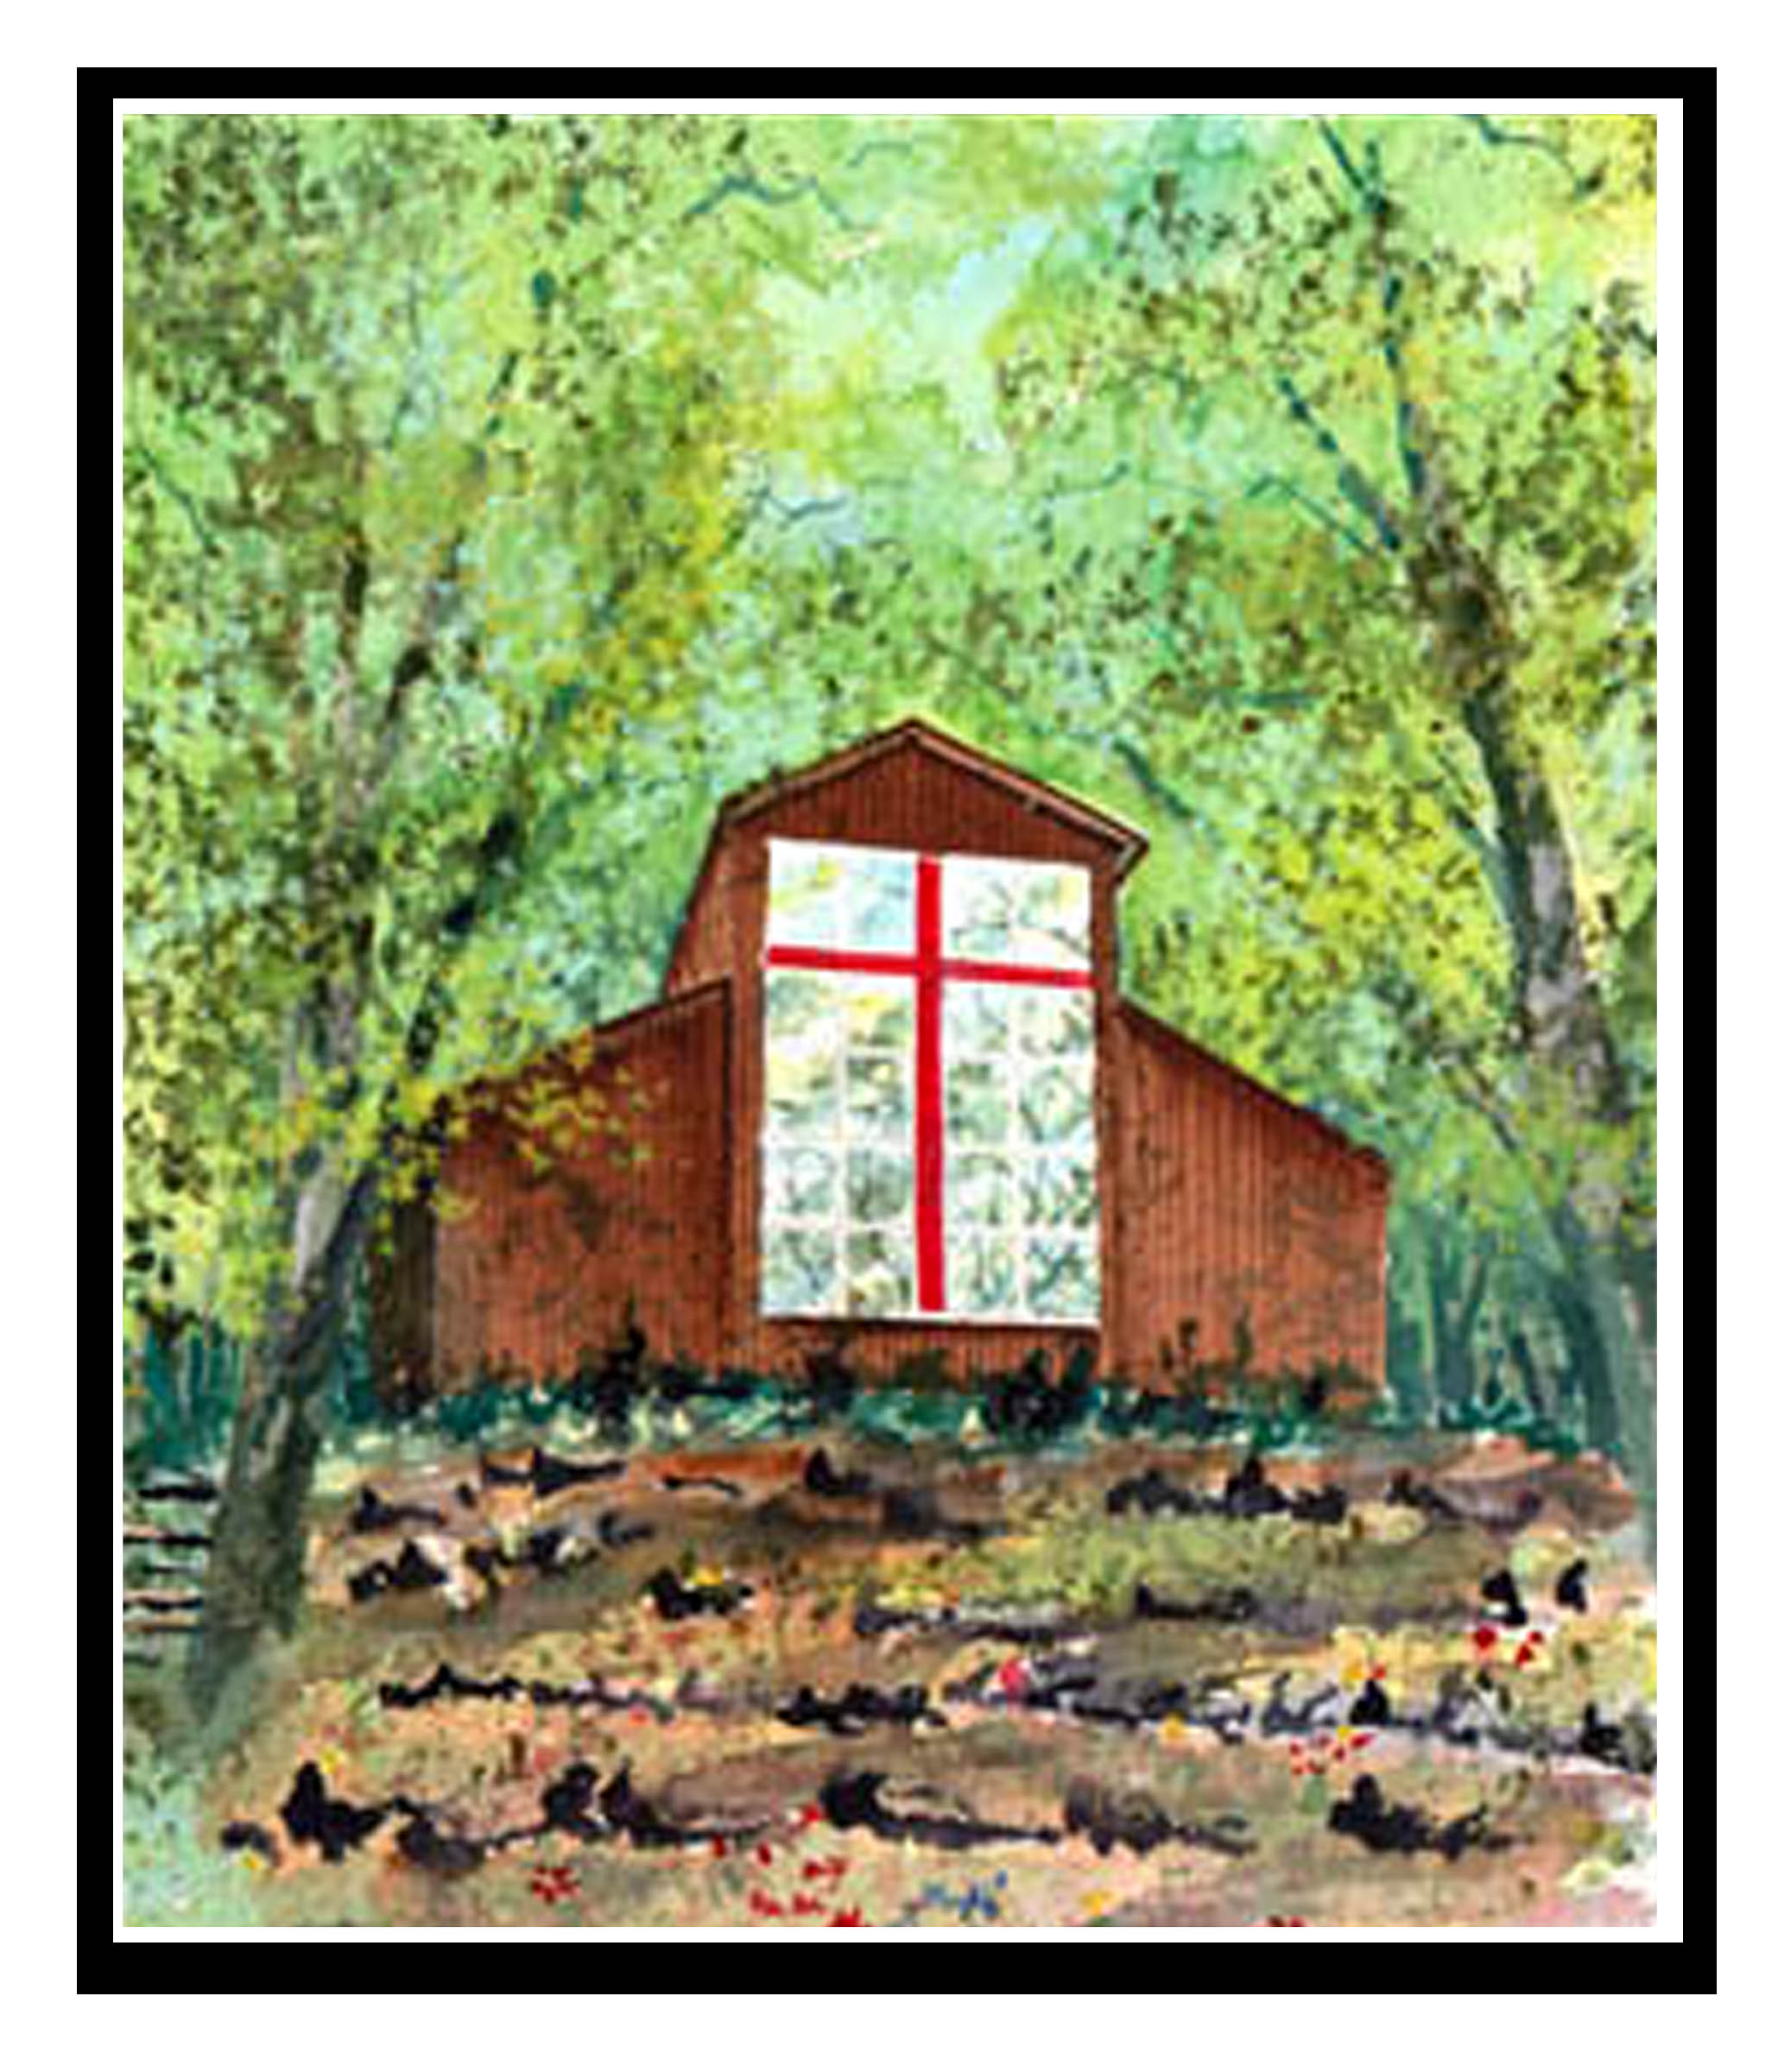

The Cathedral Domain

Gaither Print Fundraiser Commitment Form

Name__________________________________________________________________________________________

Street Address________________________________________________________________________________

City___________________________________________________State__________Zip Code_______________

Phone Number_______________________________________________________________________________

E-mail Address_______________________________________________________________________________

Yes! I want to make a five-year commitment to the Cathedral Domain. I pledge to annually donate:

_____ $1000

_____ $500

_____ $300

_____ $250
Other amount (greater than $250 annually):______________________________________________

Print Delivery

_____ I prefer to have the framed print shipped directly to me. I have included $20 to cover the cost of shipping with my first payment.

_____ I prefer to pick up the framed print in person at The Mission House (Lexington, KY). Please contact me with further details.

Payment Information

_____ My check is enclosed for my first annual payment. (Make checks payable to the Cathedral Domain.)

_____ I prefer to pay by credit card. (Mastercard or Visa)

Card Number _________________________________________________________________________________

Exp. Date_________ Security Code_________ Amount Authorized____________________________
(Or visit www.cathedraldomain.org, click ‘Donate’ button and add ‘Gaither Print’ for the memo.)

Signature of Donor:__________________________________________________________________________

